Mysql Comprehensive Assessment

Topic : Library Management System

You are going to build a project based on Library Management System. It keeps track of all information about books in the library, their cost, status and total number of books available in the library.

Create a database named library and following TABLES in the database:

1. Branch

2. Employee

3. Books

4. Customer

5. IssueStatus

6. ReturnStatus

Attributes for the tables:

1. Branch

• Branch_no

* Set as PRIMARY KEY   
  • Manager_Id   
  • Branch_address   
  • Contact_no

2. Employee

• Emp_Id – Set as PRIMARY KEY

• Emp_name

• Position

• Salary

• Branch_no

* Set as FOREIGN KEY and it refer Branch_no in Branch table

3. Books

• ISBN

* Set as PRIMARY KEY   
  • Book_title   
  • Category   
  • Rental_Price   
  • Status [Give yes if book available and no if book not available]   
  • Author   
  • Publisher

4. Customer

• Customer_Id

* Set as PRIMARY KEY   
  • Customer_name   
  • Customer_address   
  • Reg_date

5. IssueStatus

• Issue_Id

* Set as PRIMARY KEY   
  • Issued_cust – Set as FOREIGN KEY and it refer customer_id in CUSTOMER table Issued_book_name   
  • Issue_date   
  • Isbn_book – Set as FOREIGN KEY and it should refer isbn in BOOKS table

6. ReturnStatus

• Return_Id

* Set as PRIMARY KEY   
  • Return_cust   
  • Return_book_name   
  • Return_date   
  • Isbn_book2
* Set as FOREIGN KEY and it should refer isbn in BOOKS table

**Code:**

create database library;

use library;

create table branch (branch_no int primary key, manager_id int, branch_address varchar (200), contact_no varchar(15));

create table employee (emp_id int primary key, emp_name varchar(50), position varchar(40), salary decimal(10, 2), branch_no int, foreign key (branch_no)

references branch(branch_no));

create table books (isbn varchar(20) primary key, book_title varchar(200), category varchar(100), rental_price decimal(10,2), status enum('yes','no'),

author varchar(100), publisher varchar(100));

create table customer (customer_id int primary key, customer_name varchar(50), customer_address varchar(200), reg_date date);

create table issuestatus (issue_id int primary key, issued_cust int, issued_book_name varchar(200), issue_date date, isbn_book varchar(15),

foreign key (issued_cust) references customer(customer_id), foreign key (isbn_book) references books(isbn));

create table returnstatus (return_id int primary key, return_cust int, return_book_name varchar(200), return_date date, isbn_book2 varchar(15),

foreign key (return_cust) references customer(customer_id), foreign key (isbn_book2) references books(isbn));

insert into branch (branch_no, manager_id, branch_address, contact_no) values (1, 101, '123 MG Road, Bengaluru', '08012345678'),

(2, 102, '456 Park Street, Kolkata', '03312345678'), (3, 103, '789 Connaught Place, New Delhi', '01112345678'), (4, 104, '321 Anna Salai, Chennai', '04412345678'),

(5, 105, '654 JM Road, Pune', '02012345678');

insert into employee (emp_id, emp_name, position, salary, branch_no) values (1, 'Amit Sharma', 'Manager', 70000, 1), (2, 'Sonal Patel', 'Librarian', 50000, 1),

(3, 'Rahul Verma', 'Assistant Librarian', 30000, 2), (4, 'Neha Gupta', 'Manager', 75000, 2), (5, 'Priya Reddy', 'Librarian', 48000, 3), (6, 'Rohan Singh', 'Assistant Librarian', 32000, 3),

(7, 'Meera Joshi', 'Manager', 72000, 4), (8, 'Karan Mehta', 'Librarian', 51000, 4), (9, 'Anjali Rao', 'Assistant Librarian', 29000, 5), (10, 'Vikram Das', 'Manager', 68000, 5);

insert into books (isbn, book_title, category, rental_price, status, author, publisher) values

('1234567890123', 'The Great Indian Novel', 'Fiction', 70.00, 'yes', 'Shashi Tharoor', 'Penguin India'),

('2345678901234', 'The Immortals of Meluha', 'Fantasy', 60.00, 'no', 'Amish Tripathi', 'Westland'),

('3456789012345', 'The Argumentative Indian', 'Non-Fiction', 80.00, 'yes', 'Amartya Sen', 'Penguin'),

('4567890123456', 'The White Tiger', 'Fiction', 55.00, 'yes', 'Aravind Adiga', 'HarperCollins'),

('5678901234567', 'Chanakyas Chant', 'Historical Fiction', 65.00, 'no', 'Ashwin Sanghi', 'Westland'),

('6789012345678', 'India After Gandhi', 'History', 90.00, 'yes', 'Ramachandra Guha', 'Picador'),

('7890123456789', 'Five Point Someone', 'Fiction', 45.00, 'yes', 'Chetan Bhagat', 'Rupa & Co.'),

('8901234567890', 'The Monk Who Sold His Ferrari', 'Self-help', 50.00, 'no', 'Robin Sharma', 'Jaico Publishing House'),

('9012345678901', 'Wings of Fire', 'Autobiography', 70.00, 'yes', 'A.P.J. Abdul Kalam', 'Universities Press'),

('0123456789012', '2 States', 'Fiction', 60.00, 'yes', 'Chetan Bhagat', 'Rupa & Co.'),

('9780670086409', 'The Shiva Trilogy', 'Fantasy', 75.00, 'no', 'Amish Tripathi', 'Westland'),

('8765432109876', 'My Experiments with Truth', 'Autobiography', 85.00, 'yes', 'Mahatma Gandhi', 'Penguin'),

('7654321098765', 'Sapiens', 'Non-Fiction', 95.00, 'yes', 'Yuval Noah Harari', 'Penguin Random House'),

('6543210987654', 'The Oath of the Vayuputras', 'Fantasy', 70.00, 'no', 'Amish Tripathi', 'Westland'),

('5432109876543', 'I Too Had a Love Story', 'Romance', 40.00, 'yes', 'Ravinder Singh', 'Penguin'),

('4321098765432', 'Half Girlfriend', 'Romance', 50.00, 'yes', 'Chetan Bhagat', 'Rupa & Co.'),

('3210987654321', 'How to Win Friends and Influence People', 'Self-help', 55.00, 'yes', 'Dale Carnegie', 'Westland'),

('2109876543210', 'The Power of Your Subconscious Mind', 'Self-help', 60.00, 'no', 'Joseph Murphy', 'Penguin'),

('1098765432109', 'Rich Dad Poor Dad', 'Finance', 65.00, 'yes', 'Robert T. Kiyosaki', 'Plata Publishing'),

('9876543210987', 'The Alchemist', 'Fiction', 70.00, 'yes', 'Paulo Coelho', 'HarperCollins'),

('9780553296983', 'Foundation', 'Science Fiction', 75.00, 'yes', 'Isaac Asimov', 'Bantam Books'),

('9780345538376', 'A Game of Thrones', 'Fantasy', 80.00, 'yes', 'George R.R. Martin', 'Bantam Books'),

('9780385537858', 'The Da Vinci Code', 'Thriller', 85.00, 'no', 'Dan Brown', 'Doubleday'),

('9780140177398', 'Of Mice and Men', 'Classic', 90.00, 'yes', 'John Steinbeck', 'Penguin'),

('9780143039433', 'To Kill a Mockingbird', 'Classic', 95.00, 'yes', 'Harper Lee', 'J.B. Lippincott & Co.'),

('9780061120084', 'The Road', 'Post-Apocalyptic', 100.00, 'no', 'Cormac McCarthy', 'Knopf'),

('9780743273565', 'The Great Gatsby', 'Classic', 105.00, 'yes', 'F. Scott Fitzgerald', 'Scribner'),

('9780439139595', 'Harry Potter and the Goblet of Fire', 'Fantasy', 110.00, 'yes', 'J.K. Rowling', 'Scholastic'),

('9781400079988', 'Life of Pi', 'Adventure', 115.00, 'no', 'Yann Martel', 'Mariner Books'),

('9781400031705', 'Middlesex', 'Fiction', 120.00, 'yes', 'Jeffrey Eugenides', 'Picador'),

('9780553386790', 'The Kite Runner', 'Drama', 125.00, 'yes', 'Khaled Hosseini', 'Riverhead Books'),

('9780743487452', 'Angels and Demons', 'Thriller', 130.00, 'yes', 'Dan Brown', 'Pocket Books'),

('9780451524935', '1984', 'Dystopian', 135.00, 'yes', 'George Orwell', 'Signet Classics'),

('9780345803481', 'Fifty Shades of Grey', 'Romance', 140.00, 'no', 'E.L. James', 'Vintage Books'),

('9780060850524', 'Brida', 'Fiction', 145.00, 'yes', 'Paulo Coelho', 'HarperCollins'),

('9780062315007', 'The Goldfinch', 'Fiction', 150.00, 'yes', 'Donna Tartt', 'Little, Brown and Company'),

('9781501139154', 'It', 'Horror', 155.00, 'yes', 'Stephen King', 'Scribner'),

('9780553382563', 'A Thousand Splendid Suns', 'Drama', 160.00, 'yes', 'Khaled Hosseini', 'Riverhead Books'),

('9780143127741', 'The Girl on the Train', 'Thriller', 165.00, 'yes', 'Paula Hawkins', 'Riverhead Books'),

('9780316769488', 'The Catcher in the Rye', 'Classic', 170.00, 'yes', 'J.D. Salinger', 'Little, Brown and Company'),

('9780812981605', 'The Nightingale', 'Historical Fiction', 175.00, 'yes', 'Kristin Hannah', 'St. Martins Press'),

('9780141439600', 'Jane Eyre', 'Classic', 180.00, 'yes', 'Charlotte Brontë', 'Penguin'),

('9781408855690', 'Harry Potter and the Philosophers Stone', 'Fantasy', 185.00, 'yes', 'J.K. Rowling', 'Bloomsbury'),

('9780679734772', 'Beloved', 'Historical Fiction', 190.00, 'yes', 'Toni Morrison', 'Knopf'),

('9780345804044', 'Fifty Shades Darker', 'Romance', 195.00, 'no', 'E.L. James', 'Vintage Books'),

('9781501128035', 'The Stand', 'Horror', 200.00, 'yes', 'Stephen King', 'Doubleday'),

('9780307474278', 'The Road', 'Post-Apocalyptic', 205.00, 'no', 'Cormac McCarthy', 'Knopf'),

('9780385490818', 'The Lovely Bones', 'Fiction', 210.00, 'yes', 'Alice Sebold', 'Little, Brown and Company'),

('9781400068652', 'All the Light We Cannot See', 'Historical Fiction', 215.00, 'yes', 'Anthony Doerr', 'Scribner'),

('9781400033416', 'Middlesex', 'Fiction', 220.00, 'yes', 'Jeffrey Eugenides', 'Picador'),

('9780316556347', 'The Silent Patient', 'Thriller', 225.00, 'yes', 'Alex Michaelides', 'Celadon Books'),

('9780316489749', 'Before We Were Strangers', 'Romance', 230.00, 'yes', 'Renée Carlino', 'Atria Books'),

('9780670020552', 'The Goldfinch', 'Fiction', 235.00, 'yes', 'Donna Tartt', 'Little, Brown and Company'),

('9780671020200', 'The Underground Railroad', 'Historical Fiction', 240.00, 'yes', 'Colson Whitehead', 'Doubleday'),

('9780399590504', 'The Immortalists', 'Fiction', 245.00, 'yes', 'Chloe Benjamin', 'G.P. Putnams Sons'),

('9780735224315', 'Where the Crawdads Sing', 'Mystery', 250.00, 'yes', 'Delia Owens', 'G.P. Putnams Sons'),

('9780812993547', 'The Night Circus', 'Fantasy', 255.00, 'yes', 'Erin Morgenstern', 'Doubleday'),

('9780185754729', 'The Fault in Our Stars', 'Young Adult', 260.00, 'yes', 'John Green', 'Dutton Books'),

('9780439023481', 'The Hunger Games', 'Dystopian', 265.00, 'yes', 'Suzanne Collins', 'Scholastic'),

('9780735224312', 'Where the Crawdads Sing', 'Mystery', 270.00, 'yes', 'Delia Owens', 'G.P. Putnams Sons'),

('9780316389739', 'Before We Were Strangers', 'Romance', 275.00, 'yes', 'Renée Carlino', 'Atria Books'),

('9781400033426', 'Middlesex', 'Fiction', 280.00, 'yes', 'Jeffrey Eugenides', 'Picador'),

('9780316256347', 'The Silent Patient', 'Thriller', 285.00, 'yes', 'Alex Michaelides', 'Celadon Books'),

('9780671120552', 'The Goldfinch', 'Fiction', 290.00, 'yes', 'Donna Tartt', 'Little, Brown and Company'),

('9780670020200', 'The Underground Railroad', 'Historical Fiction', 295.00, 'yes', 'Colson Whitehead', 'Doubleday'),

('9780399591504', 'The Immortalists', 'Fiction', 300.00, 'yes', 'Chloe Benjamin', 'G.P. Putnams Sons'),

('9780812193547', 'The Night Circus', 'Fantasy', 305.00, 'yes', 'Erin Morgenstern', 'Doubleday'),

('9780235224315', 'Where the Crawdads Sing', 'Mystery', 310.00, 'yes', 'Delia Owens', 'G.P. Putnams Sons'),

('9780316556387', 'The Silent Patient', 'Thriller', 315.00, 'yes', 'Alex Michaelides', 'Celadon Books'),

('9780385390818', 'The Lovely Bones', 'Fiction', 320.00, 'yes', 'Alice Sebold', 'Little, Brown and Company'),

('9781410033416', 'Middlesex', 'Fiction', 325.00, 'yes', 'Jeffrey Eugenides', 'Picador'),

('9780316389729', 'Before We Were Strangers', 'Romance', 330.00, 'yes', 'Renée Carlino', 'Atria Books'),

('9780385154729', 'The Fault in Our Stars', 'Young Adult', 335.00, 'yes', 'John Green', 'Dutton Books'),

('9780735124315', 'Where the Crawdads Sing', 'Mystery', 340.00, 'yes', 'Delia Owens', 'G.P. Putnams Sons'),

('9780316556317', 'The Silent Patient', 'Thriller', 345.00, 'yes', 'Alex Michaelides', 'Celadon Books'),

('9780385190818', 'The Lovely Bones', 'Fiction', 350.00, 'yes', 'Alice Sebold', 'Little, Brown and Company'),

('9781400043416', 'Middlesex', 'Fiction', 355.00, 'yes', 'Jeffrey Eugenides', 'Picador'),

('9780385752729', 'The Fault in Our Stars', 'Young Adult', 360.00, 'yes', 'John Green', 'Dutton Books'),

('9780714224315', 'Where the Crawdads Sing', 'Mystery', 365.00, 'yes', 'Delia Owens', 'G.P. Putnams Sons'),

('9780316551347', 'The Silent Patient', 'Thriller', 370.00, 'yes', 'Alex Michaelides', 'Celadon Books'),

('9780382490818', 'The Lovely Bones', 'Fiction', 375.00, 'yes', 'Alice Sebold', 'Little, Brown and Company'),

('9781400083416', 'Middlesex', 'Fiction', 380.00, 'yes', 'Jeffrey Eugenides', 'Picador'),

('9780316389719', 'Before We Were Strangers', 'Romance', 385.00, 'yes', 'Renée Carlino', 'Atria Books'),

('9780385752229', 'The Fault in Our Stars', 'Young Adult', 390.00, 'yes', 'John Green', 'Dutton Books'),

('9780735234315', 'Where the Crawdads Sing', 'Mystery', 395.00, 'yes', 'Delia Owens', 'G.P. Putnams Sons'),

('9780316526347', 'The Silent Patient', 'Thriller', 400.00, 'yes', 'Alex Michaelides', 'Celadon Books');

insert into customer (customer_id, customer_name, customer_address, reg_date) values (1, 'Ravi Kumar', '123 Lakshmi Nagar, Delhi', '2021-01-15'),

(2, 'Suman Gupta', '456 Viman Nagar, Pune', '2021-02-20'), (3, 'Priya Singh', '789 Banjara Hills, Hyderabad', '2021-03-10'),

(4, 'Amitabh Bachchan', '123 Juhu, Mumbai', '2021-04-25'), (5, 'Rajesh Khanna', '456 MG Road, Bengaluru', '2021-05-05'),

(6, 'Kareena Kapoor', '789 Versova, Mumbai', '2021-06-15'), (7, 'Shah Rukh Khan', '123 Bandra, Mumbai', '2021-07-20'),

(8, 'Alia Bhatt', '456 Khar, Mumbai', '2021-08-30'), (9, 'Ranveer Singh', '789 Andheri, Mumbai', '2021-09-10'),

(10, 'Deepika Padukone', '123 Jayanagar, Bengaluru', '2021-10-15'), (11, 'Varun Dhawan', '456 Banjara Hills, Hyderabad', '2021-11-20'),

(12, 'Anushka Sharma', '789 Jubilee Hills, Hyderabad', '2021-12-25'), (13, 'Aamir Khan', '123 Carter Road, Mumbai', '2022-01-10'),

(14, 'Katrina Kaif', '456 Pali Hill, Mumbai', '2022-02-15'), (15, 'Hrithik Roshan', '789 Lokhandwala, Mumbai', '2022-03-20');

insert into issuestatus (issue_id, issued_cust, issued_book_name, issue_date, isbn_book) values (1, 1, 'The Great Indian Novel', '2024-07-01', '1234567890123'),

(2, 2, 'The Silent Patient', '2024-07-02', '9780316526347'), (3, 3, 'The Immortals of Meluha', '2024-07-03', '2345678901234'),

(4, 4, 'Where the Crawdads Sing', '2024-07-04', '9780735234315'), (5, 5, 'The Argumentative Indian', '2024-07-05', '3456789012345'),

(6, 6, 'The Fault in Our Stars', '2024-07-06', '9780385752229'), (7, 7, 'The White Tiger', '2024-07-07', '4567890123456'),

(8, 8, 'Before We Were Strangers', '2024-07-08', '9780316389719');

insert into returnstatus (return_Id, return_cust, return_book_name, return_date, isbn_book2) values (1, 1, 'The Great Indian Novel', '2024-07-10', '1234567890123'),

(2, 2, 'The Silent Patient', '2024-07-11', '9780316526347'), (3, 3, 'The Immortals of Meluha', '2024-07-12', '2345678901234'),

(4, 4, 'Where the Crawdads Sing', '2024-07-13', '9780735234315'), (5, 5, 'The Argumentative Indian', '2024-07-14', '3456789012345'),

(6, 6, 'The Fault in Our Stars', '2024-07-15', '9780385752229'), (7, 7, 'The White Tiger', '2024-07-16', '4567890123456'),

(8, 8, 'Before We Were Strangers', '2024-07-17', '9780316389719');

select * from books;

select * from branch;

select * from customer;

select * from employee;

select * from issuestatus;

select * from returnstatus;

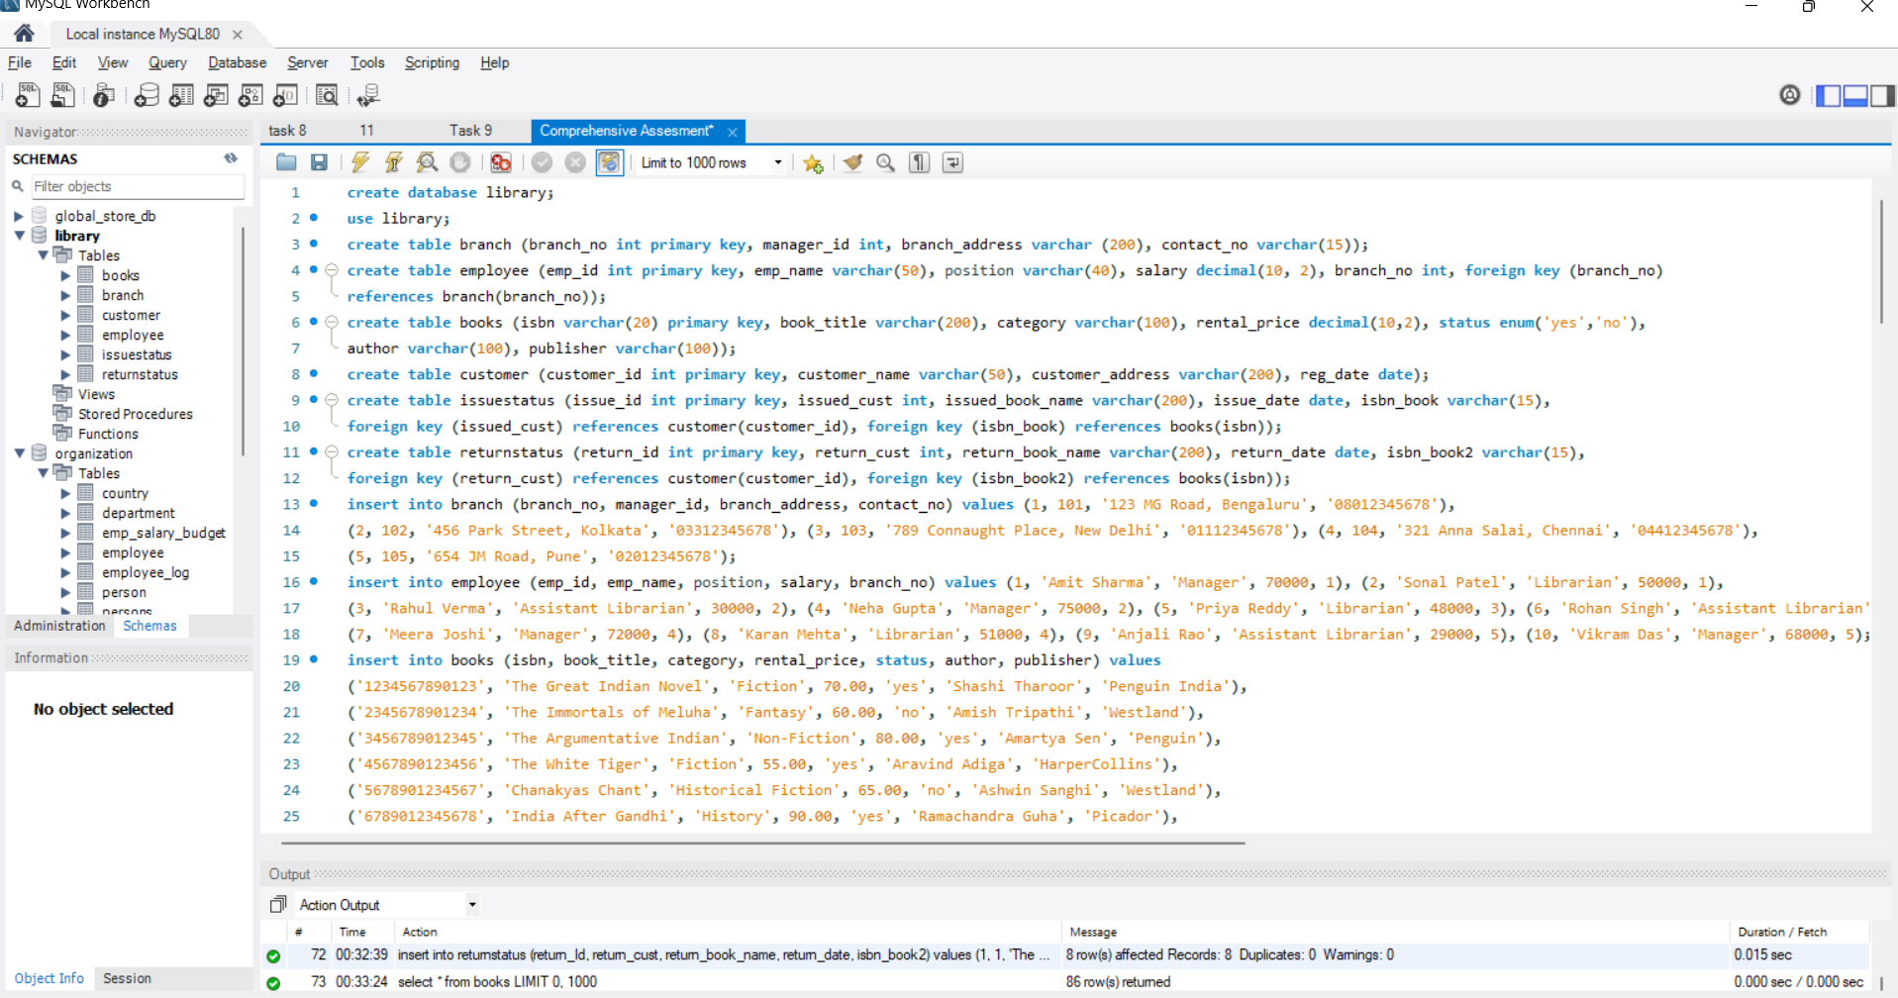

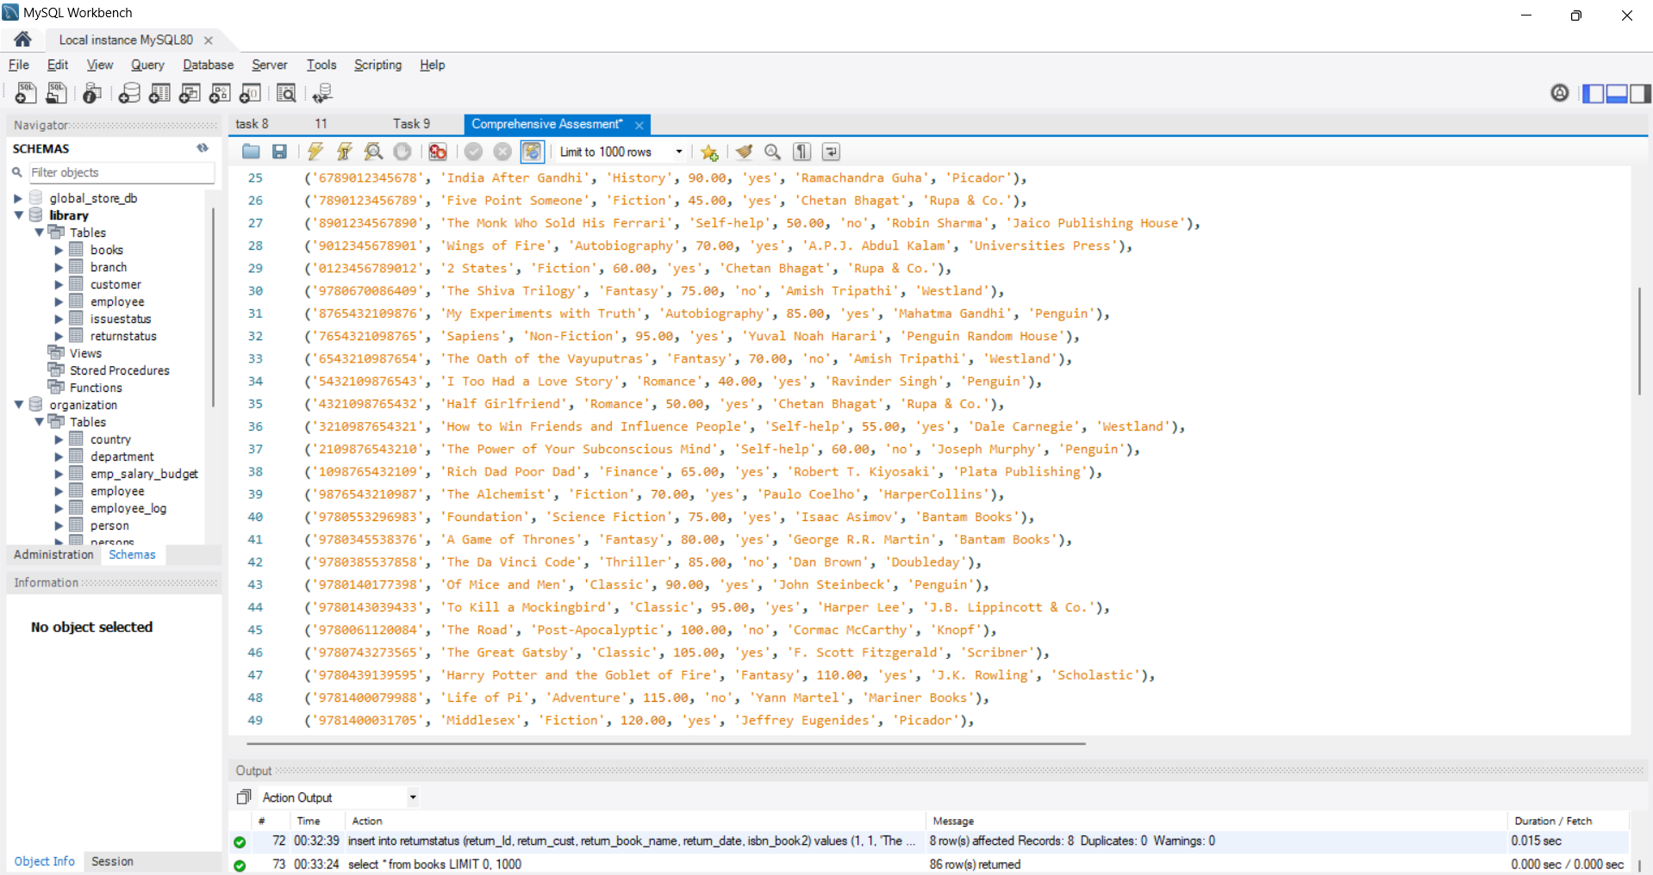

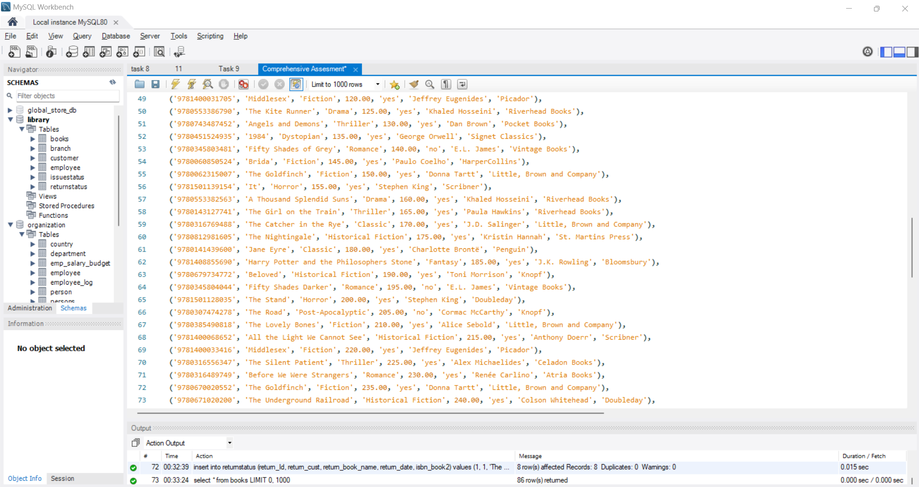

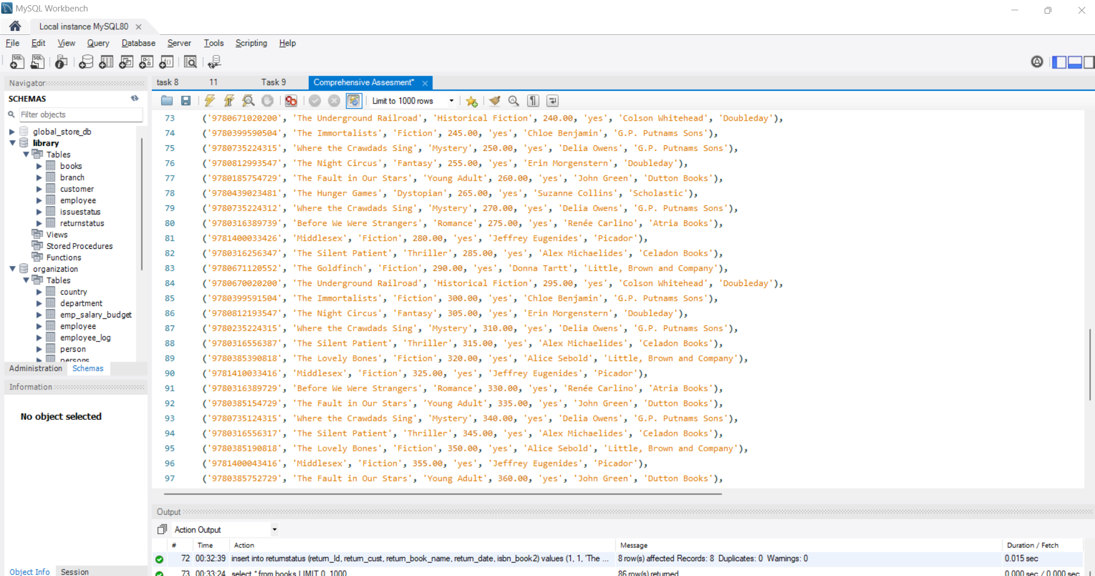

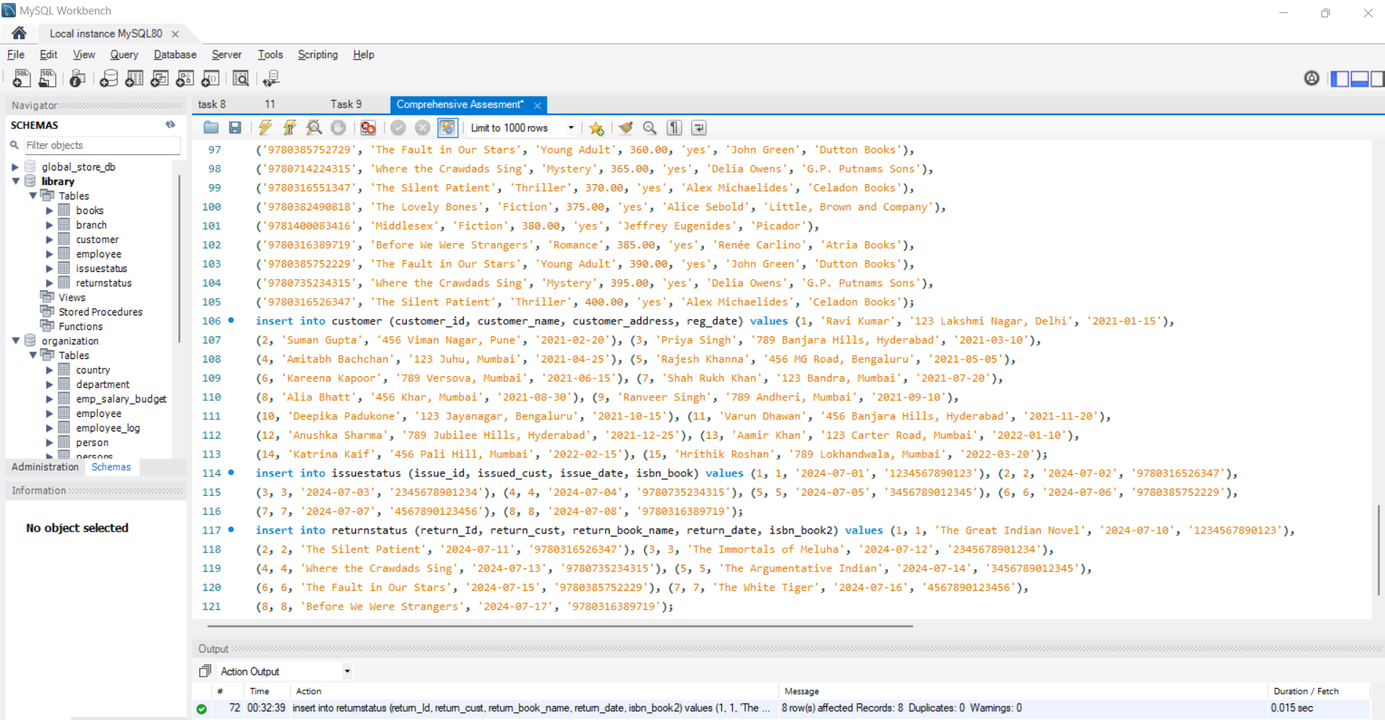

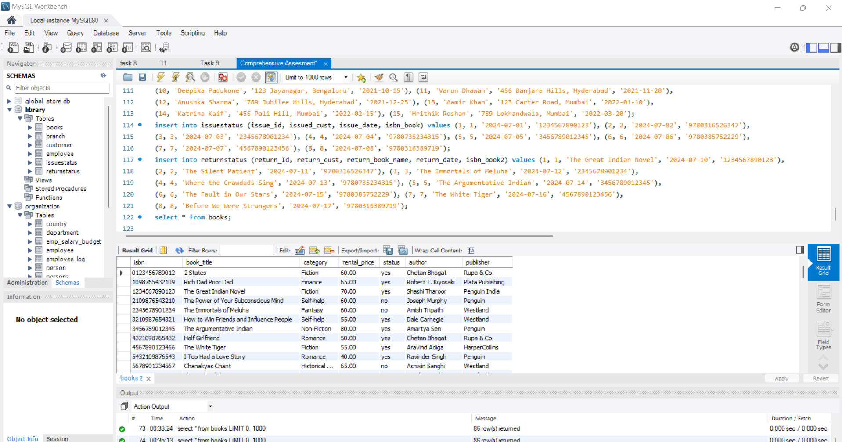

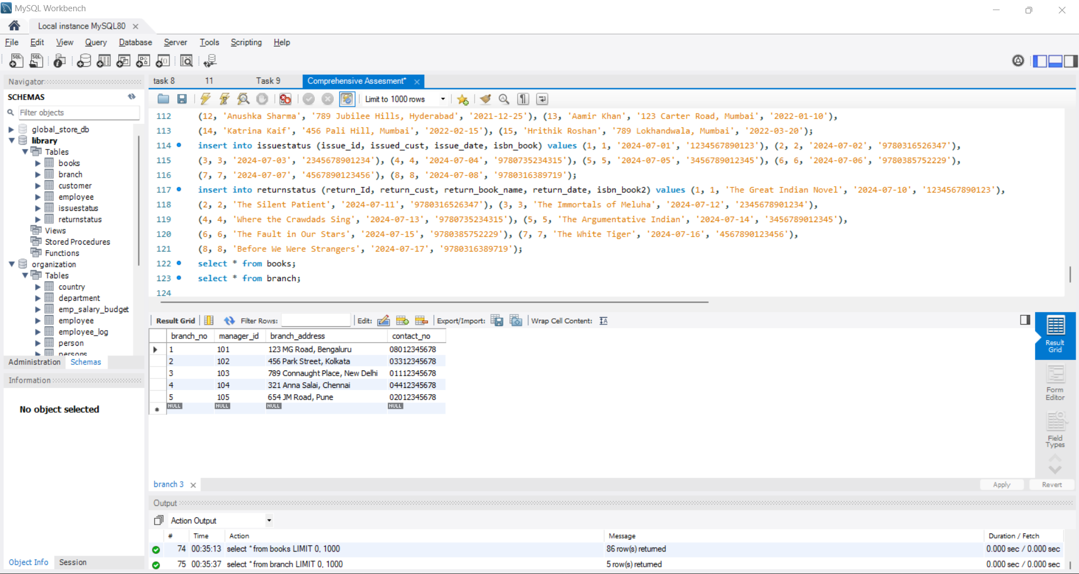

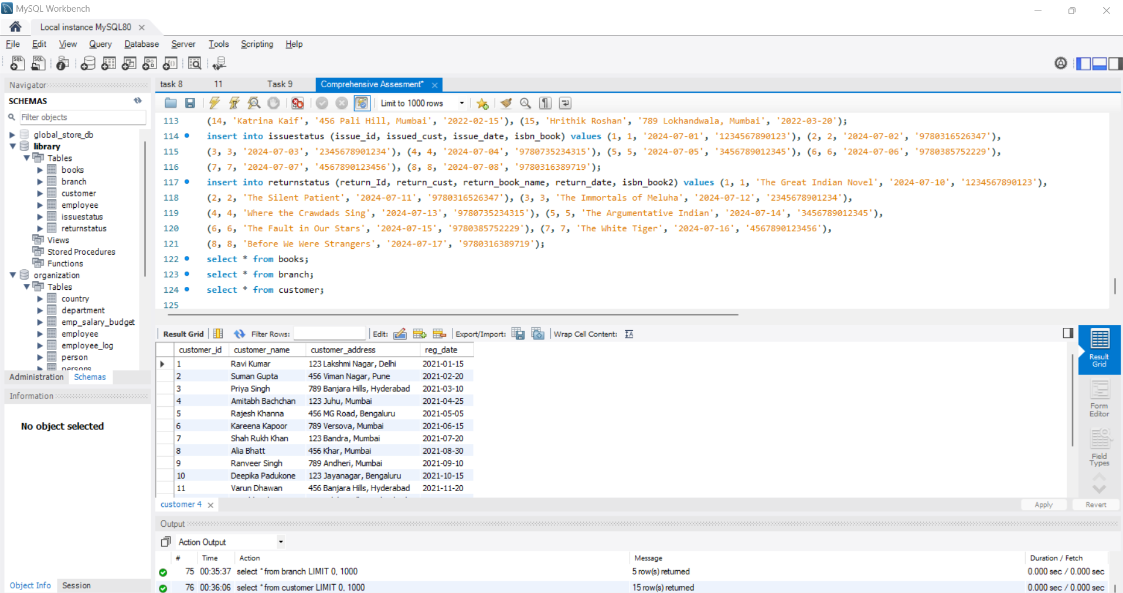

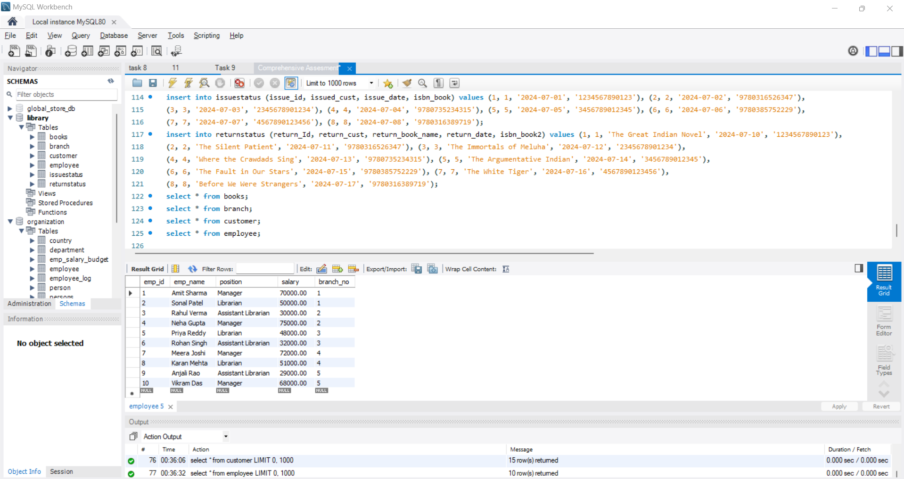

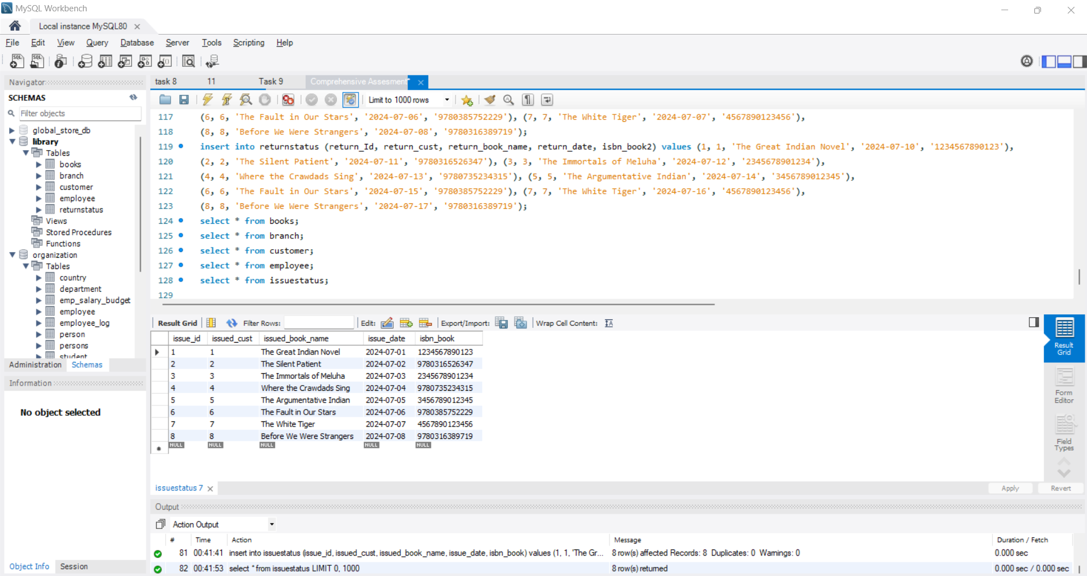

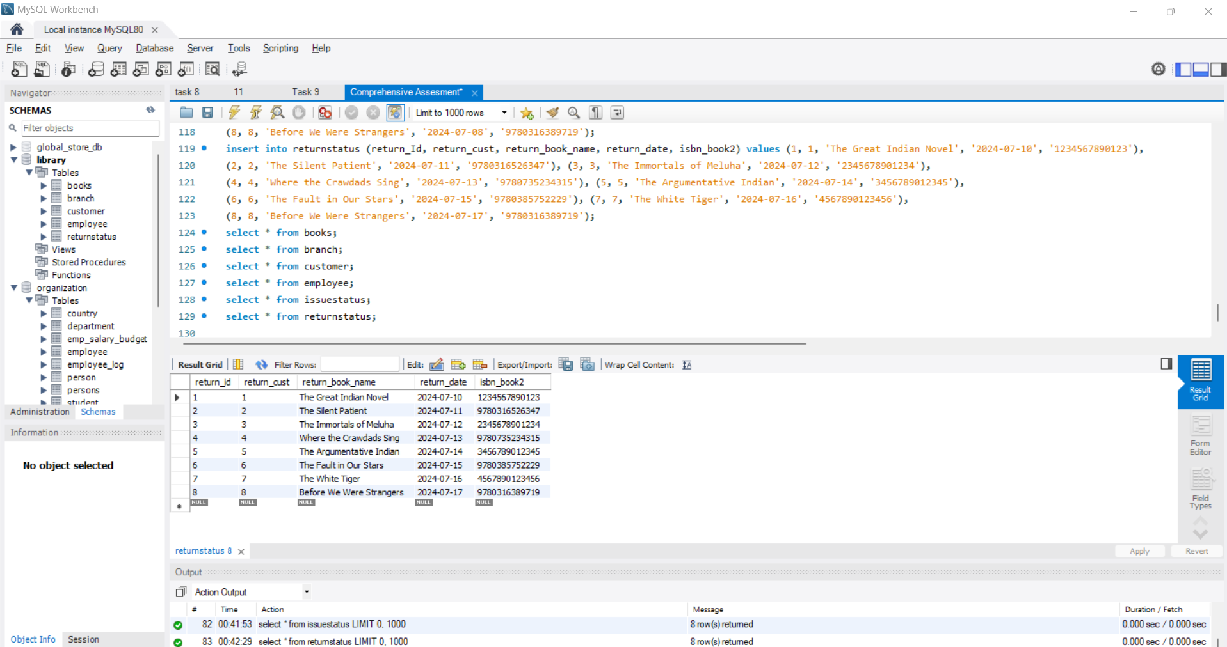

Display all the tables and Write the queries for the following :

1. Retrieve the book title, category, and rental price of all available books.

**Code:**

select book_title, category, rental_price from books where status = 'yes';

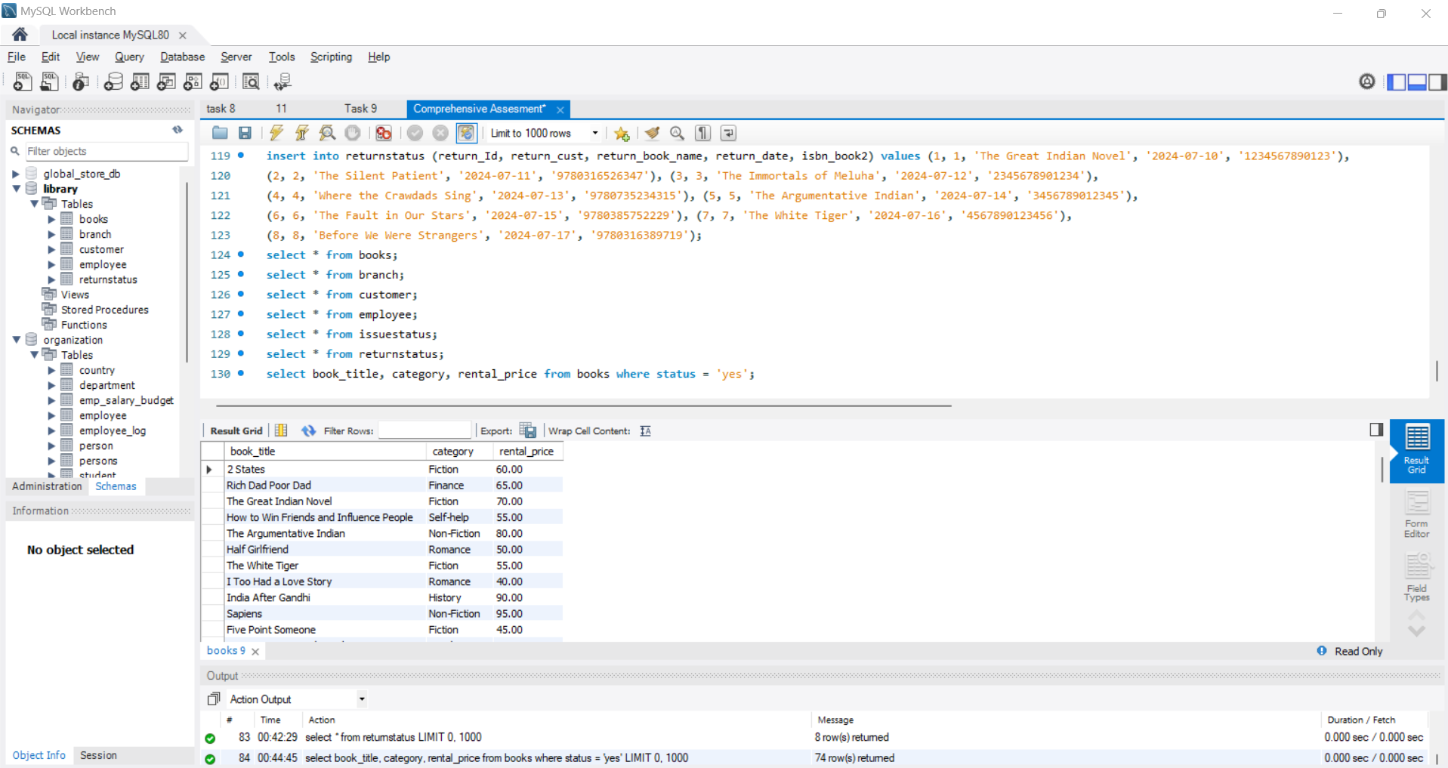

2. List the employee names and their respective salaries in descending order of salary.

**Code:**

select emp_name, salary from employee order by salary desc;

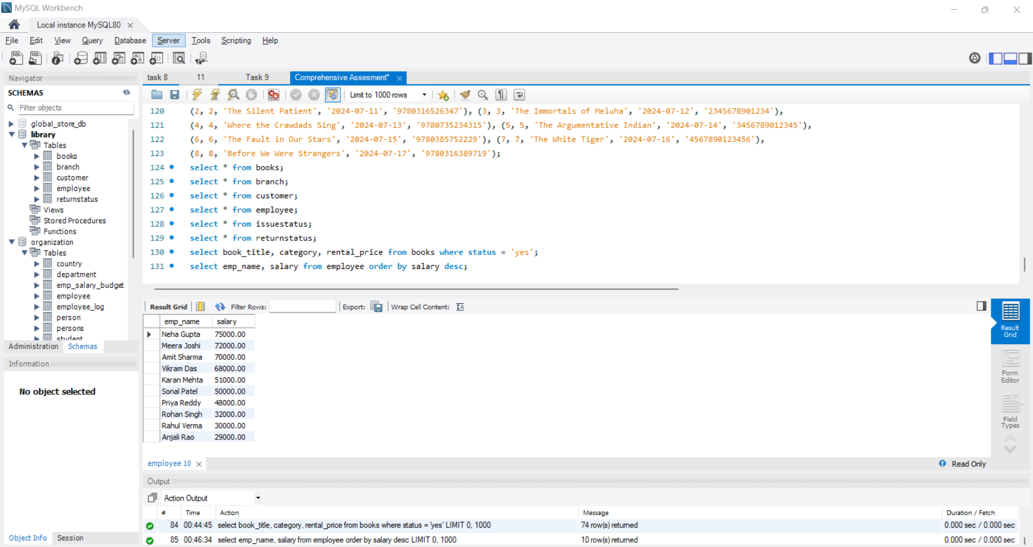

3. Retrieve the book titles and the corresponding customers who have issued those books.

**Code:**

select books.book_title, customer.customer_name from issuestatus inner join books on issuestatus.isbn_book = books.isbn inner

join customer on issuestatus.issued_cust = customer.customer_id;

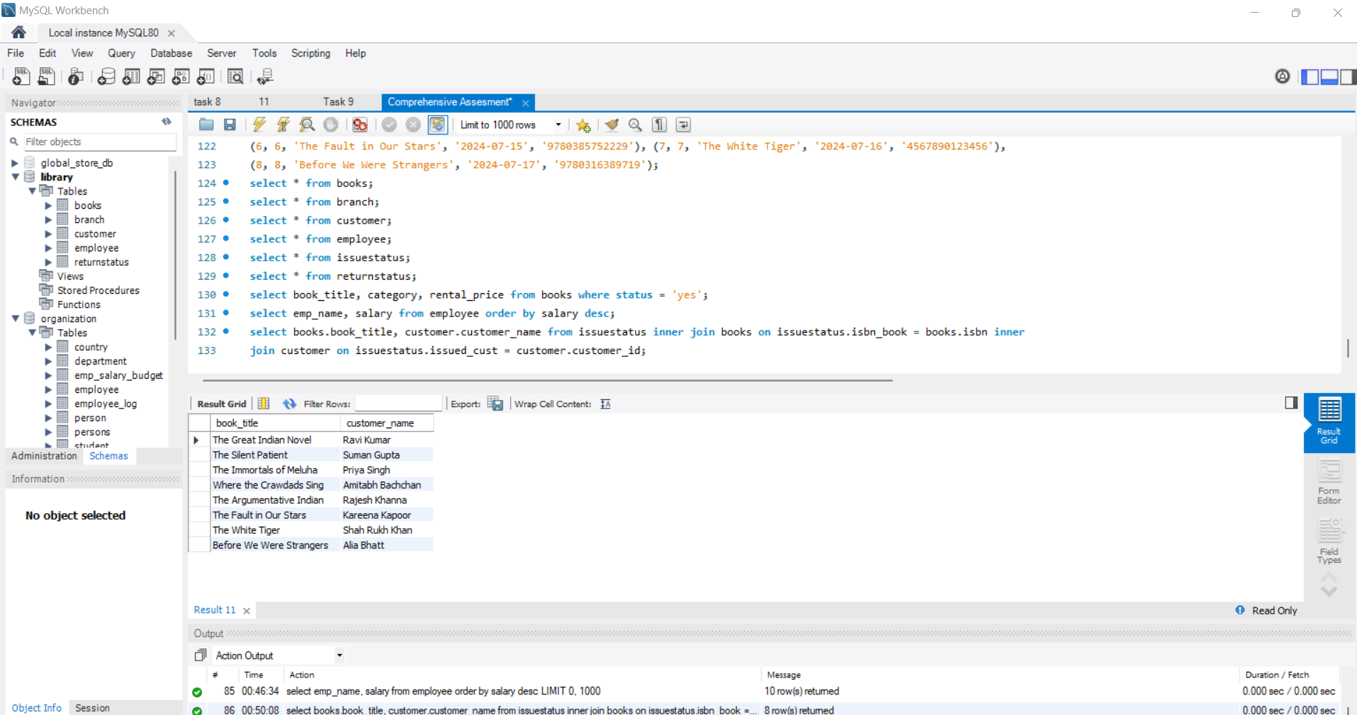

4. Display the total count of books in each category.

**Code:**

select category, COUNT(*) as total_books from books group by category;

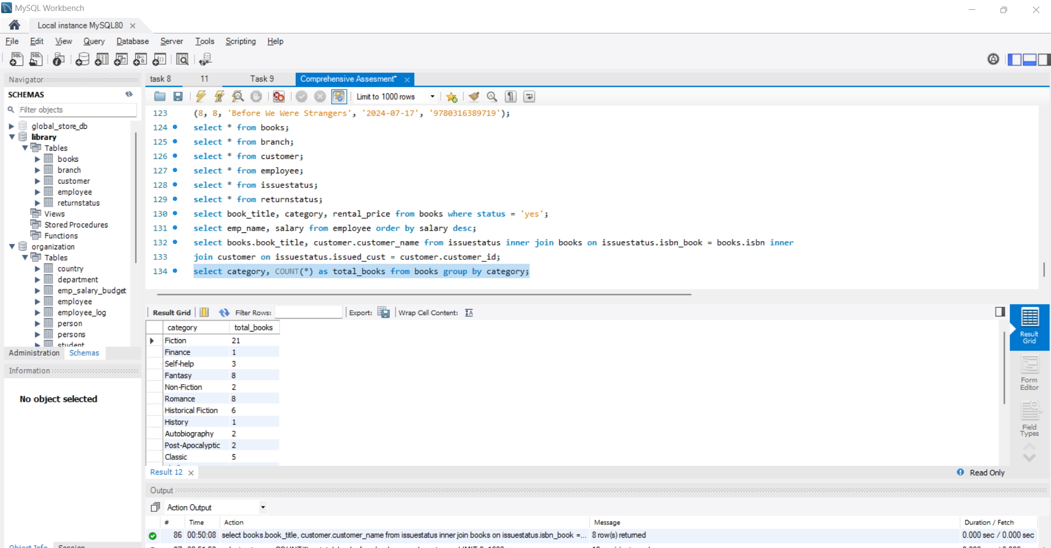

5. Retrieve the employee names and their positions for the employees whose salaries are above Rs.50,000.

**Code:**

select emp_name, position from employee where salary > 50000;

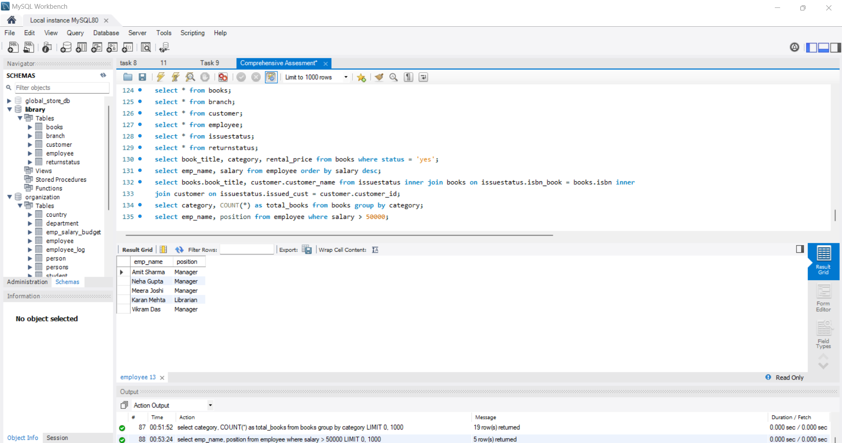

6. List the customer names who registered before 2022-01-01 and have not issued any books yet.

**Code:**

select customer.customer_name from customer left join issuestatus on customer.customer_id = issuestatus.issued_cust where customer.reg_date < '2022-01-01'

and issuestatus.issue_id is null;

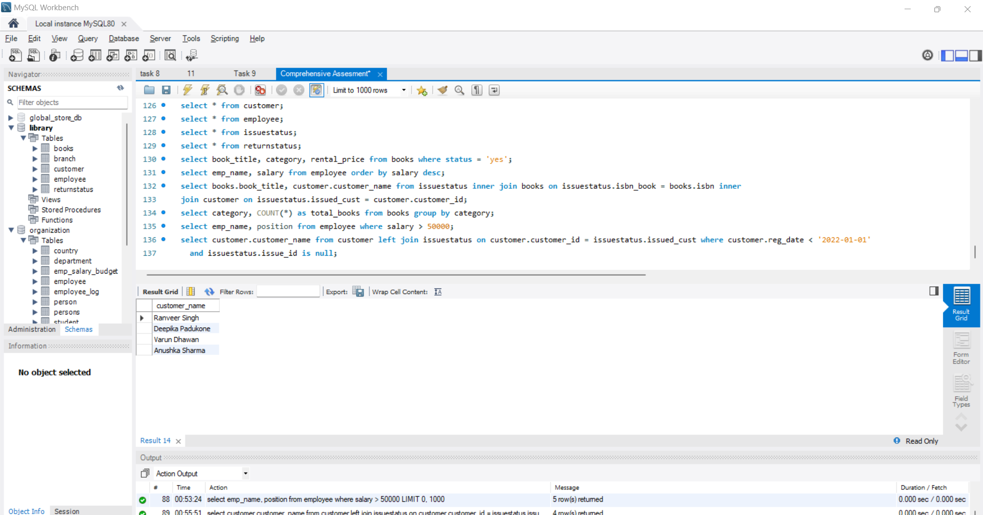

7. Display the branch numbers and the total count of employees in each branch.

**Code:**

select branch_no, count(*) as total_employees from employee group by branch_no;

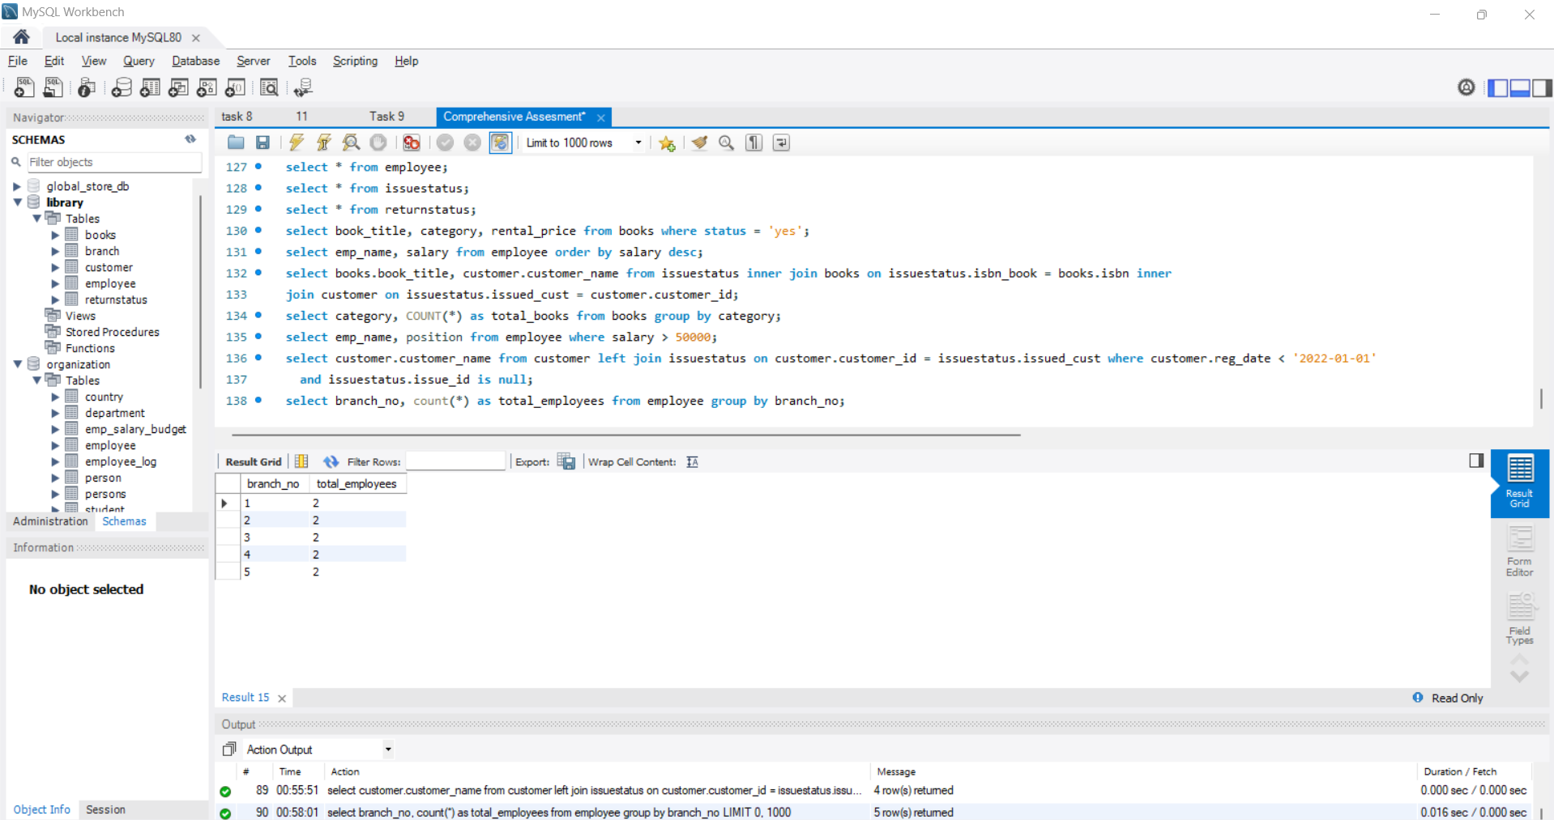

8. Display the names of customers who have issued books in the month of June 2023.

**Code:**

select distinct customer.customer_name from customer join issuestatus on customer.customer_id = issuestatus.issued_cust where

issuestatus.issue_date between '2023-06-01' and '2023-06-30';

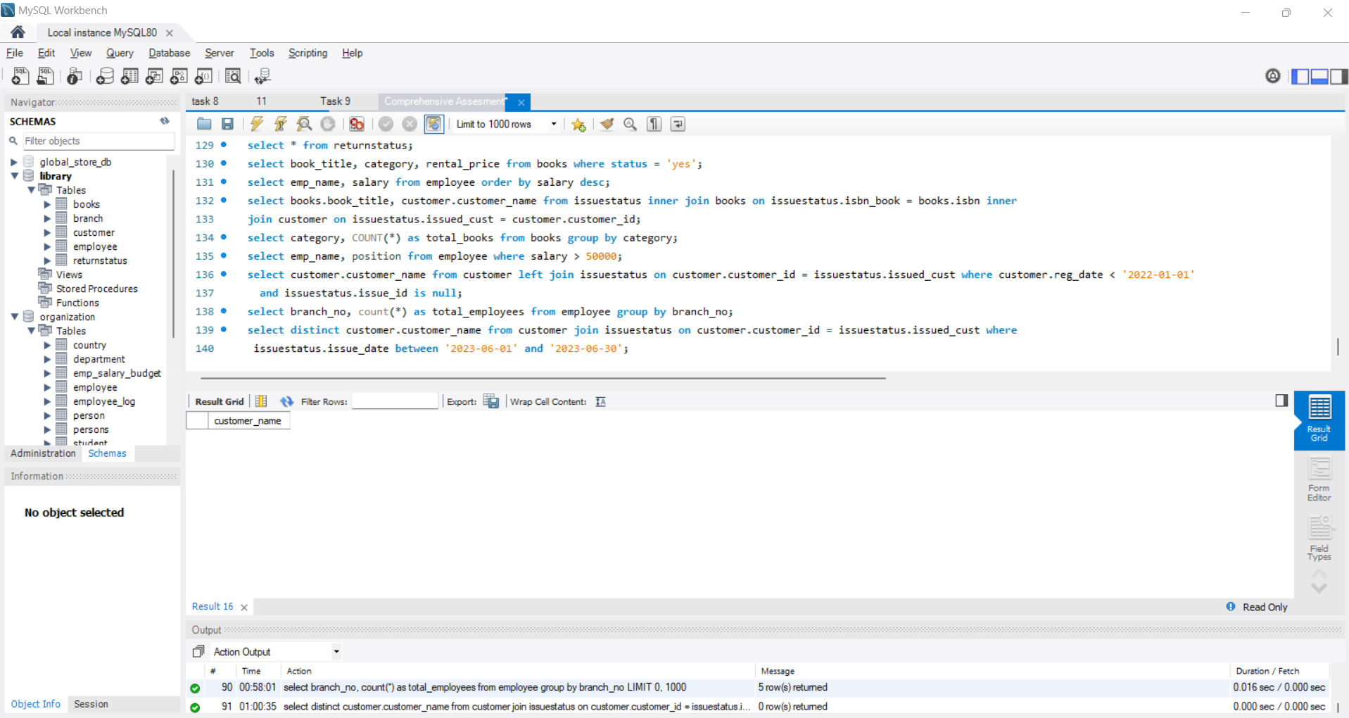

9. Retrieve book_title from book table containing history.

**Code:**

select book_title from books where book_title like '%history%';

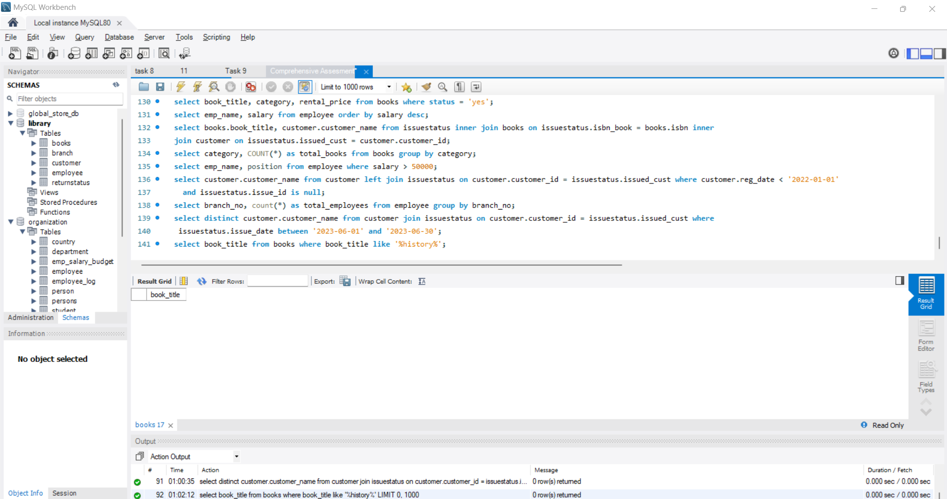

10.Retrieve the branch numbers along with the count of employees for branches having more than 5 employees

**Code:**

select branch_no, count(*) as employee_count from employee group by branch_no having count(*) > 5;

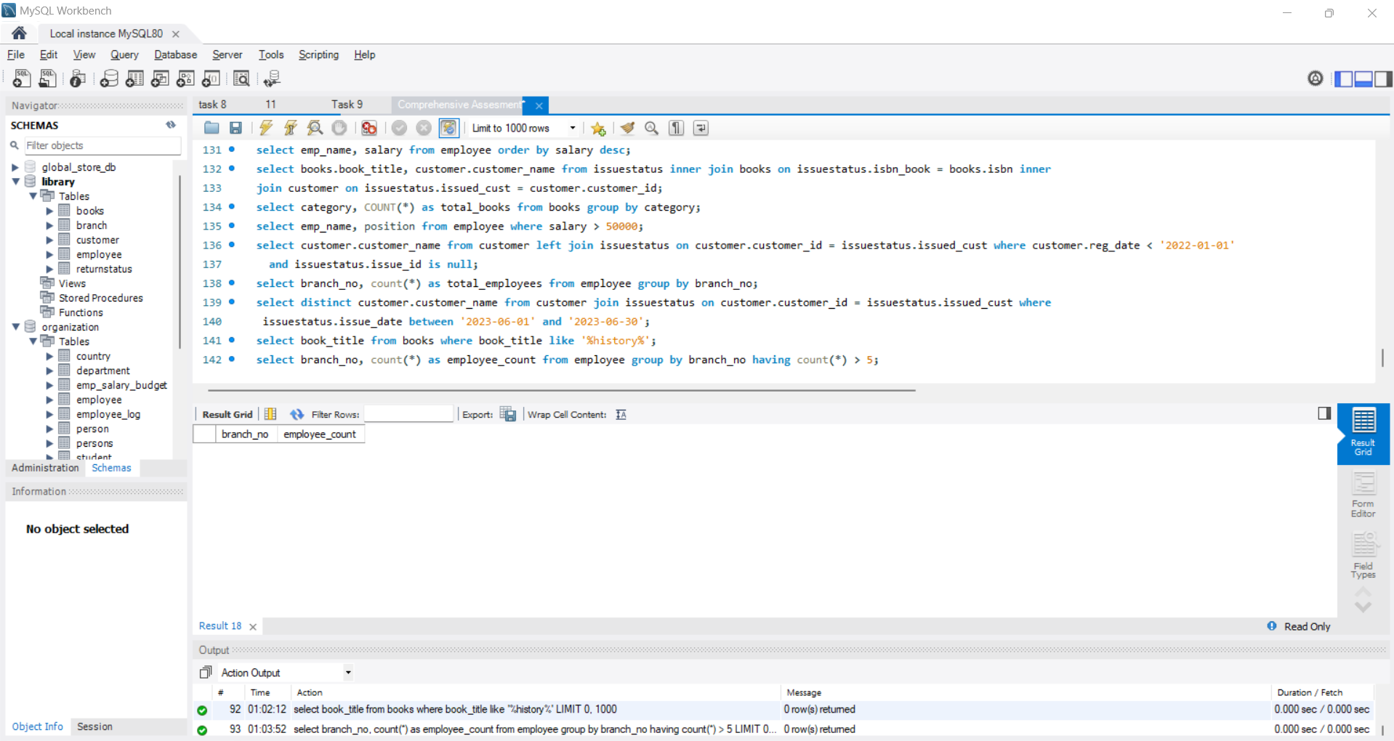

11. Retrieve the names of employees who manage branches and their respective branch addresses.

select employee.emp_name, branch.branch_address from employee inner join branch on employee.branch_no = branch.branch_no

where employee.position = 'Manager';

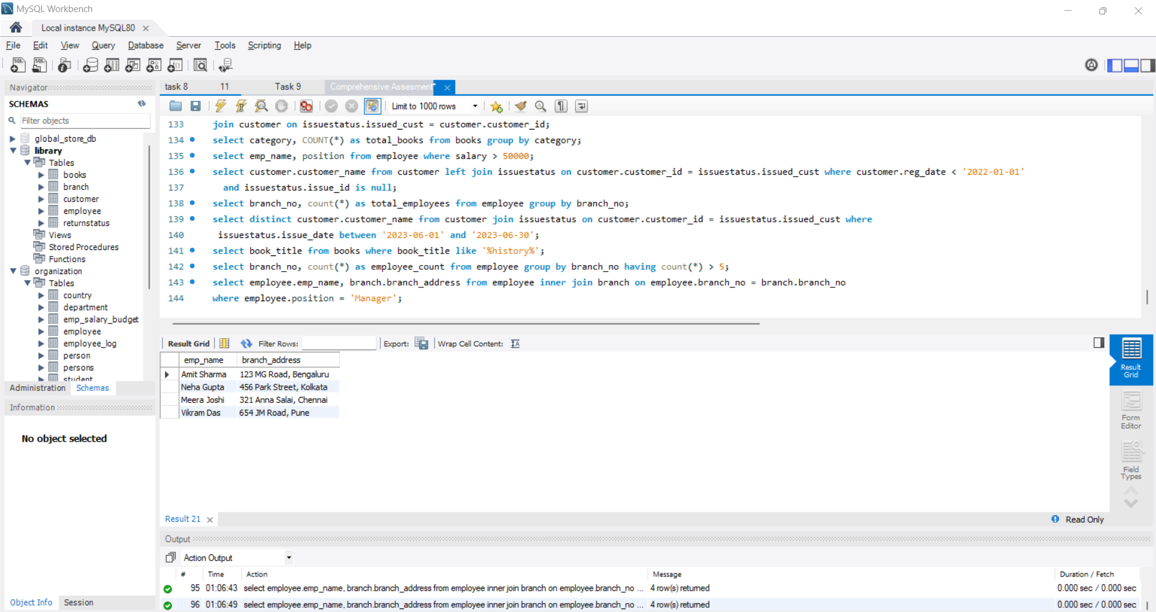

12. Display the names of customers who have issued books with a rental price higher than Rs. 25.

